Given a linked list, reverse the nodes of a linked list *k* at a time and return its modified list.

*k* is a positive integer and is less than or equal to the length of the linked list. If the number of nodes is not a multiple of *k* then left-out nodes, in the end, should remain as it is.

**Follow up:**

* Could you solve the problem in O(1) extra memory space?
* You may not alter the values in the list's nodes, only nodes itself may be changed.

**Example 1:**

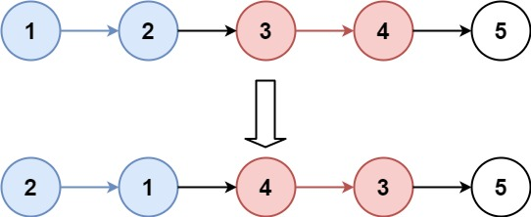

**Input:** head = [1,2,3,4,5], k = 2

**Output:** [2,1,4,3,5]

**Example 2:**

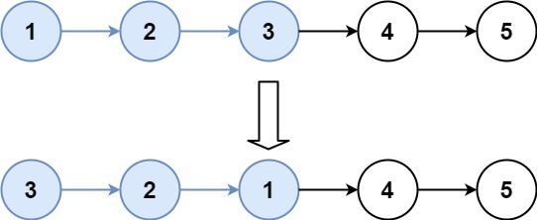

**Input:** head = [1,2,3,4,5], k = 3

**Output:** [3,2,1,4,5]

**Example 3:**

**Input:** head = [1,2,3,4,5], k = 1

**Output:** [1,2,3,4,5]

**Example 4:**

**Input:** head = [1], k = 1

**Output:** [1]

**Constraints:**

* The number of nodes in the list is in the range sz.
* 1 <= sz <= 5000
* 0 <= Node.val <= 1000
* 1 <= k <= sz